Unsolved Homicide/Murders/Missing Persons

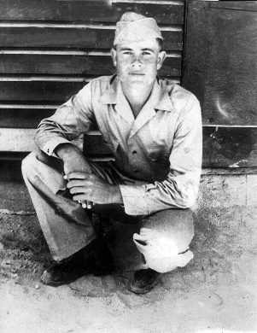
Ward Huland Herrin, “Huland” – Case Number 1982-10232
On August 10, 1982, Ward Huland Herrin checked into the Stevens Motel, room #11, at the corner of US Highway 17 & Harts Road, Yulee, Florida. According to the motel clerk, the victim was accompanied by a white female. The following morning, the murdered body of Ward Huland Herrin was discovered in his motel room. His vehicle (Datsun 1600 pickup) was discovered near Main Street & 28th street in Jacksonville, Florida.

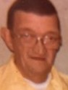
Delbert Bailey Luzader, aka “Lou” – Case Number 1983-12471
On May 28, 1983, Delbert Bailey Luzader, aka “Lou”, left his residence on Trout River Boulevard, Jacksonville, FL., and possibly stopped at Playbill’s Liquor & Package in Callahan, FL. His body was recovered on October 18, 1983 off of Crawford Road (Powerline Road), Callahan, Florida. He was wrapped in bedsheets from a local motel. His 1970’s Ford F-100 has never been recovered. (truck shown in photo)
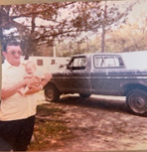

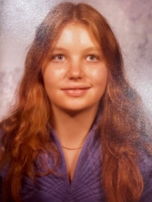
Paula Harler Blackburn – Case Number 1983-14451
Last Seen: December 3, 1983 at the Jax I-10 Truck Stop (Baldwin, Florida)
Paula Blackburn was hitchhiking and traveling South returning home to her husband and child after recently completing a trade school. Witnesses stated on December 3, 1983, they observed her at the Jax I-10 truck stop (Baldwin, Fl), in the company of one individual described as: White male with a dark complexion, approximately twenty-five (25) years of age, 5’9” tall, 200 lbs, dark eyes, dark hair combed straight back with a receding hair line. She and the individual left together by an unknown means at approximately 6PM. Paula Blackburn was estimated to have been murdered during the early hours of December 3, 1983. Her body was discovered the following morning, December 4, 1983, behind Brandy Branch Baptist Church, Bryceville, Florida, approximately six miles from the Jax I-10 Truck Stop (Baldwin, Florida).

Unidentified Jane Doe – Case number 1986-15090 MEO# 1986-1067 Located: 10/21/1986
On 10/21/1986, skeletal remains of a white female, estimated age was 21-35 years of age, height between 5’0” -6’0”, (estimated height of 5’6”), was located in an area off I-95 North in Nassau County, Florida, .9 miles South of US Highway 17 exit. Clothing found with the remains consists of a sleeveless pullover top/halter with narrow straps. (Estimated year of death 1986)

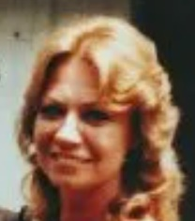
Linda Faye (Keener) Anderson – Case Number 1987-18558
Last seen: October 14, 1986 in Neptune Beach, Florida. Linda Anderson was later reported missing by her ex-husband on March 14, 1987. Her remains were located November 29, 1987 off an embankment on Interstate 10 in Nassau County.
Linda Anderson lived in Neptune Beach, FL and recently divorced. Linda was possibly living in a house/duplex in the Jacksonville Beaches area with an older white male. Her last known employer was Beaches Yellow Taxi Cab and the Jacksonville Kennel Club.

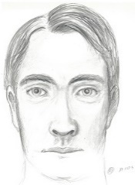
Unidentified Human Skull – Case Number 1989-19324 INV#7805 Located:10/09/1989 NAMUS#UP850
The decedent is a white male, approximately 20-30 years old, dark straight hair, with a possible healed nasal fracture. The decedent was located 4.2 miles south of A1A in Fernandina Beach, Florida on October 9, 1989. The skull was recovered in a bucket in a wooded area near an old oyster factory. The factory is located off of State Road 107, 4.2 miles south of A1A, in Fernandina Beach. No further remains were recovered. *Reconstruction of the Decedent

Unidentified Human Remains – MEO Case Number 1989-1261, NAMUS# UP863 Located: 11/28/1989
The remains/partial skull of a white female were located on November 28, 1989. The individual was the victim of an undetermined death. A partial skull was recovered in an old cemetery off of SR 108 in Nassau County. Estimated year of death 1987-1989

Shirley Lewis – Case Number 1990-27156
On December 23, 1990, Shirley J. Lewis, 62 years old, was traveling from New York to South Florida to visit her family for the holidays. After leaving the Waffle House, located on SR 200, Yulee, Florida, close to the South ramp entrance for Interstate 95, she was located inside her vehicle and had been shot twice in the head.

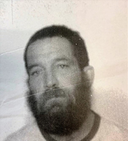
Thomas Leo Buckley - Case Number 1992-23709
On July 28, 1992, Thomas Buckley’s body was recovered on Interstate 95 South (Nassau County), near the Florida/Georgia line with an apparent gunshot wound. He was wearing a shirt that displayed, “Carpetland Florida’s Largest”, Ft. Lauderdale.

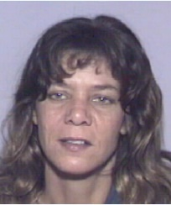
Pamela Norton Wilson, aka “Pamela Norton Ferreira” – Case Number 2009-2092,
Last seen: May 27, 1999 in Jacksonville, Florida. Pamela Wilson was released from the Duval County Correctional Facility on May 27, 1999. The mother of the decedent provided the bail bonds with extra money in order to bring her daughter back to her residence on this date.
On April 10, 2009, the remains of Pamela Wilson were located by two individuals while in Deep Creek Hunting Camp in Bryceville, Florida.
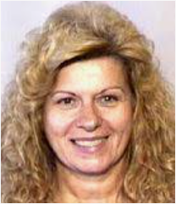
Jacquelyn Markham “Jackie” – Case Number 2000-6707
Markham was last seen at the Eckerd Pharmacy near her residence in Callahan, Florida shortly before 7:00 p.m. on December 14, 2000. According to her boyfriend, Archie Carroll, they were supposed to meet for a date later in the evening. Carroll told authorities after Markham returned home from Eckerd’s Pharmacy, Markham called him and told him a male acquaintance was at her house and that he should not come over. Carroll informed Markham he was coming over anyways. Telephone records indicate the telephone call did not take place. Markham was scheduled to leave the following morning to see her children and grandchildren.
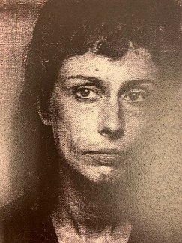
Donna Wideman – Case Number 2001-6853/2001-6253
Donna Wideman was last seen on September 24, 2001 in Jacksonville, Florida. On November 29, 2001, the decedent was located in a shallow grave off of Wildwood Road in Yulee, Florida. Wideman was known to frequent the area of 15th Street/16th Street/Hubbard Street and surrounding areas in Jacksonville, Florida.

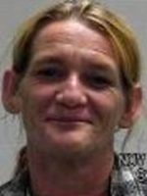
Theresa Maynette Maxwell - Case Number 2003-1678
Maxwell was last seen on Testone Lane in Hilliard, Florida on December 28, 2002. Her roommate, who is now deceased, reported her missing on April 2, 2003. He told police she had been living with him for several months prior to her disappearance. Maxwell’s daughter distinctly remembers, the last time her mother was seen was on New Year’s Eve and the last thing her mother said to her was, “I’m going to see this truck driver at Winn Dixie and I will be back”. Maxwell walked out the door and was never seen again.

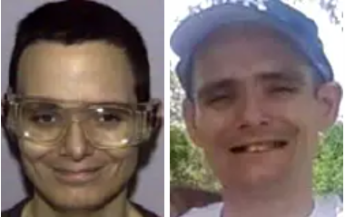
Richard James Rider, Jr. - Case Number 2011-5659
Rider was last seen leaving Dayspring Village, 55400 US Highway 1, Hilliard, Florida (Assisted Living Facility for Adults), on October 11, 20011. This was the day after his birthday.
He was walking northbound towards the Georgia state line wearing a teal shirt with green and white stripes and jean shorts. He has never been heard from again. Rider may have attempted to travel to Ohio after his disappearance.

Unidentified Human Remains – Case Number – 2014-4898, MEO Case#14-1626, NAMUS# UP13707 Located: 10/05/2014 - (DNA: mtDNA & STR done at UNT) (Entered in Codia)
The remains of a late teen or young male, unknown race, was discovered on October 5, 2014, near Tiger Island which is located within the intercoastal region of Ft. Clinch State Park, Fernandina Beach, Florida. Possible that decedent had Spina Bifida
Storage – MEO - DNA: mtDNA & STR done at UNT

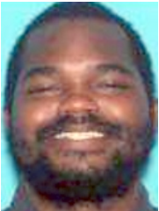
Christopher Lawrence Pollen – Case Number 2016-84048
Pollen was last seen in the Meadowfield Bluff area in Yulee, Florida at 2:00 a.m. on September 18, 2016. He left his vehicle, cellular phone and wallet at his residence and has never been heard from again.

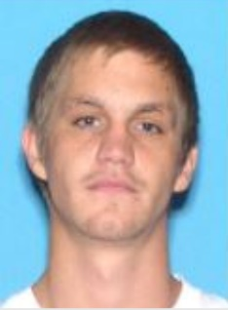
Travis Daniel Church - Case Number 2018-5279
Church was involved in a foot pursuit with a Florida Highway Patrol trooper on January 9, 2018. He was last seen running into the woods on Owens Farm Road in Yulee, Florida. He has never been heard from again. He was reported missing on January 18.
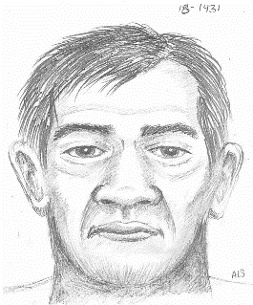

Unidentified Male - Case Number 2018-061543, MEO# 2018-1431 NAMUS#UP53438
Skeletal remains were located on the beach on Little Tiger Island in Fernandina Beach, Florida by a citizen visiting the island.
Storage – MEO
DNA: Namus, not on file (TEETH ARE AVAILABLE)

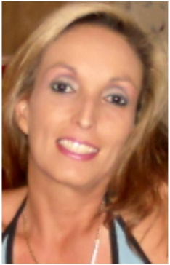
Katherine Bodden Gelaro , aka Melissa Bodden – Case Number 2019-151814
Gelaro’s was last seen on Morris Drive in Callahan, Florida on December 19, 2019. She has never been heard from again. Her two sons reported her missing on Christmas Day;
Her last location was at the home of her boyfriend, Jerry Randall Salis III. Salis has an extensive criminal record, including violent offenses. Salis is also known to travel back and forth from Callahan, Florida, Jacksonville, Florida and Baxley Georgia.
Gelaro may use the name Melissa Bodden. She has a tattoo of a design of playing cards, a heart and a banner reading ACES on the back of her shoulder.
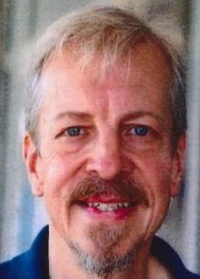
Laurence Whittemore – Case Number 2022-32525, NAMUS# MP96456
Whittemore was last seen on May 7, 2022 at 0417 hours, leaving the Dayspring Senior Living Center, Hilliard, Florida. He was wearing a blue shirt, gray shorts and dark shoes. He has salt & pepper hair with a goatee.

