Nassau County Sheriff
Sheriff Bill Leeper

Exploring Law Enforcement
- Leadership
- Integrity
- Teamwork
- Service
The Nassau County Sheriff's Office Explorer Unit is a member of Florida Sheriff’s Explorer Association. The F.S.E.A. is made up of explorer posts from around the state of Florida. Each post is comprised of young adults that are exploring the field of law enforcement. These young adults are males and females ages 13 to 21 years old.
FSEA was created to allow Sheriff's Explorers to meet quarterly for training, competition and networking. Building today’s youth into tomorrow’s leaders!

Exploring Mission Provides
- Career Opportunities
- Life Skills
- Competitive Training
- Character Education
- Leadership Experience
Law Enforcement Exploring provides educational training for youth and young adults ages 13-21 on the purposes, mission, and objectives of law enforcement. The program provides career orientation experiences, leadership opportunities, and community service activities.

Explorer Training
- CPR / First Aid
- Physical Training
- Firearm Safety & Training
- Ride-Along Safety
- Criminal Law
- Crime Scene Investigations
- Traffic Stops
- Report Writing
- Communications
- Boot Camp Training
- Corrections
- Community Involvement
- And So Much More!

Eligibility Requirements
- Be of good moral character.
- Maintain a respect for law enforcement.
- Maintain school attendance.
- Be attending or have graduated from high school or college.
- Maintain a 2.0 grade point average.
- Be between thirteen and twenty-one years of age.
- Must pass a criminal background check.
- Must be a current resident of Nassau County.

Today’s Youth, Tomorrow’s Leaders!
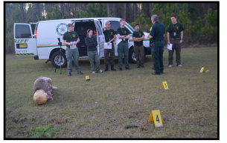
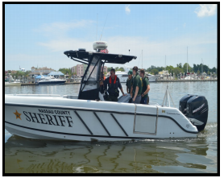
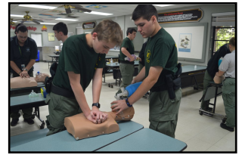
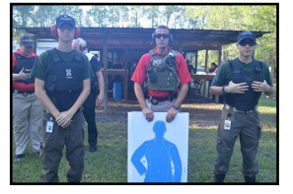

Contact Us:

Visit us online:
http://www.nassauso.com/explorer-program
Nassau County Sheriff’s Office
77151 Citizen’s Circle
(904) 225-0031
We meet the 2nd and 4th Tuesday
each month from 5:30pm-7:30pm.

The NCSO Exploring Unit is
A Non-Profit 501(3)(c) Charitable Organization

A COPY OF THE OFFICIAL REGISTRATION AND FINANCIAL INFORMATION MAY BE OBTAINED FROM THE DIVISION OF CONSUMER SERVICES BY CALLING TOLL FREE 1-800-435-7352 WITHIN THE STATE. REGISTRATION DOES NOT IMPLY ENDORSEMENT, APPROVAL, OR RECOMMENDATION BY THE STATE. FLORIDA REGISTRATION # CH39591 (NCSO Charities, Inc.) AND FLORIDA REGISTRATION # CH35945 (Ark of Nassau, Inc.). IF MAKING A DONATION PLEASE MAKE CHECKS PAYABLE TO NCSO EXPLORING UNIT.

