Nassau County Sheriff
Sheriff Bill Leeper

Prevent Firearm Accidents

Statistics
- In 2010, unintentional firearm injuries caused the deaths of 606 people.
- 2005-2010, almost 3,800 people in the United States has died from unintentional shootings.
- Over 1,300 victims of unintentional shootings for the period of 2005 - 2010 were under the age of 25.
- Unintentional shootings found that 8% of shooting deaths resulted from shots fired by children under the age of six.
- 31% of unintentional deaths caused by firearms might be prevented by the addition of two devices: a child-proof safety lock (8%) and a loaded indicted (23%).
- Unintentional injuries from firearms represent less than two percent of all firearm deaths in the U.S. But of this two percent, children and adolescents are involved in 55% of these deaths.

Undercounting Child Gun Accidents
When children are killed in unintentional shootings, medical examiners and coroners classify many as homicides, or even suicides. A detailed examination by The New York Times of death records, available in just a handful of states, found that federal statistics appeared to understate the actual count.

Responsibility Rests with You
It is the parent’s responsibility that firearms in the home are locked and put away from children. Kids must learn that guns are not toys. The National Rifle Association states that parents who accept the responsibility to learn, practice, and teach gun safety rules will ensure their child’s safety to a much greater extent than those who do not.
There is at least one firearm in more than half of American households today. Even if no one in your family owns a gun, chances are someone you know does. Your child could come in contact with a gun at a neighbor’s house, when playing with friends, or under circum- stances outside your home. It is critical that your child knows what to do in the event he or she encounters a firearm, and it is the parent’s duty to provide such training.
The National Rifle Association provides videos and brochures freely to parents and/or adults who would want to provide training to children about gun safety. To receive a copy call
(800) 231-0752.

Gun Safety
There is no particular age to begin the conversation regarding gun safety. A good indication of when is as soon as the child becomes interested in toy gun or firearms in general. Talk honestly and openly about guns instead of ordering him or her to “stay out of the gun closet.” Such statements stimulate a child’s natural curiosity to investigate further. Also, it is encouraged to discuss with children regarding the difference between toy guns and guns in real life. Children can become confused with firearms and the consequences of an action from them.

Safe Gun Motto
If you have decided that your child is not ready to be trained in a gun’s handling, teach him or her to follow the instructions of the NRA’s Eddie Eagle GunSafe® Program. Teach the child that if they find a gun: STOP! Don’t Touch. Leave the Area. Tell an Adult.
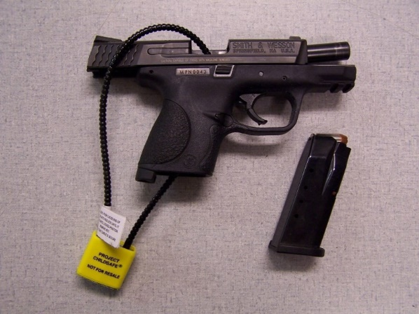

Increase Safety Awareness
Five critical rules of gun safety from the NRA and other sources:
- Always keep the gun pointed in a safe direction (whether loaded or unloaded).
- Always keep your finger off the trigger until ready to shoot.
- Always keep the gun unloaded until ready to shoot.
- Be aware of what is behind your target.
- When handling firearms, never use alcohol or any drug that might impair your awareness or judgment (including prescription drugs).
- Cable Gun locks (above) are a relatively cheap way to hinder the use of guns by young children. However, with the use of the internet, older kids can figure out how to break such locks; therefore we encourage tougher preventions such as hard case safes.

Brochure is Provided By:

Nassau County Sheriff’s Office
904-225-0031
Emergency: 9-1-1
Visit us online at www.nassauso.com

