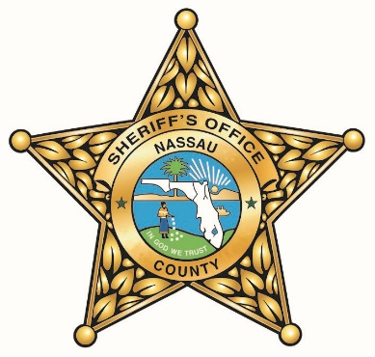

NASSAU COUNTY SHERIFF’S OFFICE

CORRECTIONS ACADEMY

SPONSORSHIP OPPORTUNITY

The Nassau County Sheriff’s Office is currently seeking qualified applicants for sponsorship to attend the Corrections Academy as a Detention Deputy Trainee. Those who have a desire to commit to a criminal justice career as a Detention Deputy with the Nassau County Sheriff’s Office are encouraged to apply.

Qualified candidates to be a Detention Deputy Trainee are those who meet the following requirements:

- Must be 19 years of age or older
- Have a high school diploma or equivalent
- Have a valid passing score on the Corrections – Criminal Justice Basic Abilities Test - to be submitted with the application
- Be a U. S. citizen or permanent resident alien who has applied for citizenship
- Possess a valid driver’s license
- If applicable, must have been discharged from the Armed Forces with an Honorable Discharge. (If an applicant received a General discharge under honorable conditions, the discharge and re-enlistment code will be investigated before continuing the hiring process.)
- Be of good moral character
- Willing and able to work shifts, holidays and weekends
- Have no visible tattoos above the collarbone (neck, face, or behind the ear) or below the wrist (hands, fingers, etc.)
- Willing to sign a two (2) year commitment agreement with the NCSO
- Have the physical capability to:
- Perform a Vertical Jump
- Perform Sit-ups for one (1) minute
- Run 300 meters
- Perform Push-ups
- Complete a 1.5 mile run/walk in 19 minutes or less

Candidates for the Sponsorship Program will be required to submit to a detailed Background Investigation, Interview / Oral Board, Polygraph Examination, Psychological Evaluation, Complete Physical, Drug Screen, and Fingerprints. The importance of disclosing on the application all information that may be discovered through the above methods cannot be expressed strongly enough.

If selected for participation in this opportunity, the Detention Deputy Trainee will be a full time civilian employee. They will be provided with comprehensive benefits and paid an hourly salary of $17.8130. The Nassau County Sheriff’s office will cover the full cost of tuition, uniforms, books, State Officer Certification Exam, and any required equipment.

Upon graduating from the academy, passing the State Officer Certification Exam, and successfully completing the NCSO Orientation Training, the Detention Deputy Trainee will be reclassified as a Detention Deputy. They would then become a full time Sworn employee, and will begin receiving the full starting salary of a Detention Deputy as is in place at the time of their reclassification.

As a newly Sworn employee they will being Special Risk High Rate retirement through the Florida Retirement System. The Detention Deputy will then begin the Field Training (FTO) Program. Once successfully completing FTO the Detention Deputy will be considered “solo” and not requiring the constant supervision of a Field Training Officer or others in the Chain of Command. At this point the two (2) years outlined in the commitment agreement will begin.

The Nassau County Sheriff’s Office offers a comprehensive benefits package to include: Health, Dental, Vision, Life, Long Term Disability Insurance, and participation in the Florida Retirement System. Also included is Paid Time Off (PTO), Holiday Pay, Longevity Pay, and a Step Pay Plan (once classified as a Sworn employee).

The Nassau County Sheriff’s Office encourages Veterans and anyone interested in a rewarding career in Corrections to apply.

For information on how to apply or to have any questions answered, please contact the Human Resources Department at:

HUMANRESOURCES@NASSAUSO.COM
www.NASSUSO.COM

The Nassau County Sheriff’s Office
Is an
Equal Opportunity Employer
And a
Drug Free Workplace

