Ride Along Program Request/Release Form

Application Date:
NOTE: This completed form must be submitted to the appropriate Watch Commander at least five (5) days prior to the ride along.
PERSONAL, DATA (Type or print legibly in BLUE ink)
NAME:
RACE:
SEX:
DATE OF BIRTH:
OTHER NAMES USE:
EMAIL:
ADDRESS:
PHONE:
Work [ ] Home [ ] Daytime [ ] (please indicate which of these describes the Phone # provided)
CITY:
STATE:
ZIP:
DL# or ID Card #:
SOCIAL SECURITY #:
Place of Employment or School:
Reason for Riding:

PERSON TO NOTIFY IN CASE OF AN EMERGENCY
Name:
Relationship:
Street:
City:
State:
Zip:
Phone #:

RELEASE AND WAIVER OF LIABILITY AND CLAIMS AND COVENANT NOT TO SUE
The Nassau County Sheriff’s Office ("NCSO") is pleased that you have chosen to participate in our Ride-Along Program We would like you to be fully aware of the conditions under which this program operates:
- You will be assigned to ride with a regular deputy of NCSO. You will be assigned to normal patrol duties and will respond to all calls for service assigned.
- Deputies are often assigned duties which involve danger and serious risks. The deputy with whom you are riding will not avoid or disregard duties which involve emergencies or danger simply because you are present with the deputy.
- You will be expected to strictly adhered to the guidelines as set out on Page 4 herein.

I, the undersigned, [print first, middle and last name], a volunteer participant of the Nassau County Sheriff's Office Ride-Along Program (hereafter "Program"), in consideration for the privilege of participation with Program, the receipt and sufficiency of consideration is hereby accepted and acknowledged, do hereby release, waive, satisfy, and forever discharge and settle any and all claims, demands, causes of action, suits, controversies, judgments or damages of any kind or nature whatsoever, in law or in equity, which exist or may arise against Bill Leeper as Sheriff of Nassau County, or his successors, heirs, assigns, employees, appointees or agents, relating to any and all participation by me in Program, in whatever activity or form, including but not limited to, injury, illness or death, and/or damage to, or loss of, personal property. The undersigned has full understanding and appreciation of all risks and dangers associated with the Program, including but not limited to, contact with criminal suspects and potentially violent or armed individuals, answering calls for service or other law enforcement tasks. The undersigned hereby assumes all risks of personal injury, death, property damage or other loss that might arise from my participation in the aforementioned.
This General Waiver and Release of Liability (hereafter "Release") shall be indefinitely and perpetually binding upon the undersigned and his/her respective heirs executors, administrators, personal representatives, successors, assigns, agents or employees. This Release will be subject to, and governed by, the laws of the State of Florida. This Release has been read and fully understood by the undersigned. It is acknowledged and agreed the undersigned has voluntarily, knowingly, and willingly executed this Release.
MEDCIAL TREATMENT AUTHORIZATION
I further understand and agree that should I be injured while participating in the program, the Nassau County Sheriff’s Office is authorized, at their discretion, to procure medical treatment for me, and that such treatment shall be at my own expense and not at the expense of the Nassau County Sheriff's Office.
SIGNATURE OF PARTICIPANT:
DATE:
WITNESS #1:
WITNESS#2:
(One witness must be a Parent or Guardian, if Participant is under 18 years of age, or Employee's Supervisor if NCSO Employee)
Sworn to and subscribed before me this day of [month], 20XX , by [Participant name], who produced a [State] driver's license with number [list driver's license number and photo copy license] as identification, and who acknowledged to and before me that he executed the foregoing document freely and voluntarily for the purposes therein expressed.
NOTARY PUBLIC:
MY COMMISSION EXPIRES:
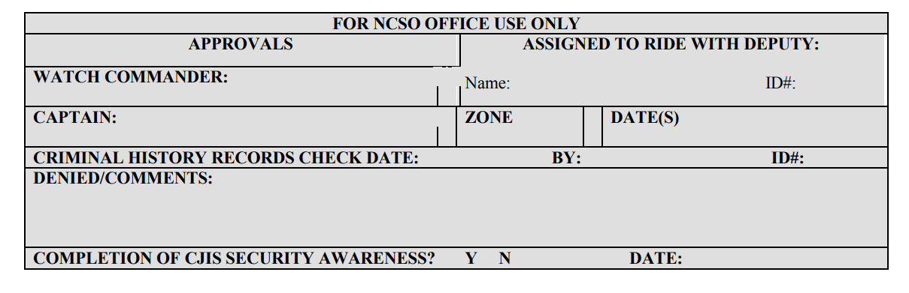

RIDE-ALONG GUIDELINES

The following guidelines have been established to make the program safe and beneficial to all. Please read; when you submit your request to ride along with a deputy sheriff you will be asked to sign a copy of these guidelines.
- Observers shall report to the Sheriff’s Office, station or sub-station, designated by the Watch Commander thirty (30) minutes prior to roll call.
- Observers shall he unarmed unless otherwise authorized by the Sheriff.
- Observers shall be neat and clean in appearance and attire. Decisions regarding questionable attire or appearance shall be made by the Watch Commander, or if the Watch Commander is not on duty, the Sergeant on duty will make the decision. Observer not appropriately attired will not be allowed to ride.
- Observers have no law enforcement authority and are under the direct authority of the deputy to whom they are assigned.
- Observers shall not interfere with any police officer performing his/her duty.
- Observers shall not: become involved in any investigation, handle evidence, discuss any case with victim(s), witnesses or suspect(s), or handle police equipment without authorization from the deputy.
- Observers shall abide by the assigned host deputy's decision as to whether or not they will be allowed to exit the vehicle and observe particular calls for law enforcement service.
- Observers are allowed to take notes, but shall not bring nor use tape recorders, cameras or video equipment (media representatives may be exempt from this rule).
- Observers may be called to Court as a witness as a result of participating in the program.
- The Sheriff, Undersheriff, Director of Operations, Patrol Captain, Watch Commander, Supervisor of assigned host deputy, assigned host deputy or Observer may terminate the ride-along at any time it is deemed necessary to benefit the participant and/or the Sheriff’s Office.
- Observers, once approved, are permitted to ride one time within any two week period unless otherwise approved by the Sheriff The Ride-Along Form is valid for a thirty (90) day period, however, any provisions, covenants, or agreements pertaining to a Release and Waiver of Liability and Claims and Covenant Not to Sue shall not expire and are perpetually applicable.
- Observers shall submit this request and included Release and Waiver Of Liability and Claims and Covenant Not to Sue at least five (5) days prior to the date which he/she wishes to ride.
- Observers will be limited to six (6) hours per shift.
- No observers will be allowed to ride with a deputy after midnight unless approved by the Watch Commander.
- Observers shall complete the required FDLE CJIS Level I Security Awareness training at least five (5) days prior to the date which he/she wishes to ride.

