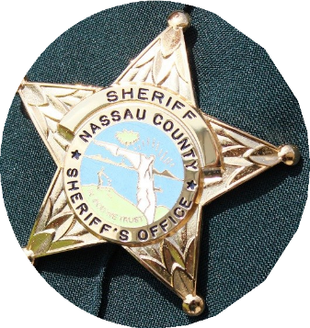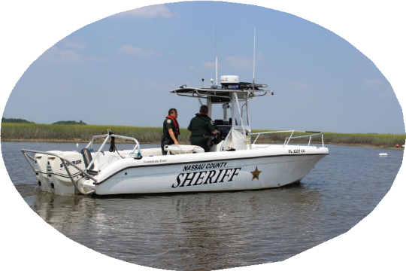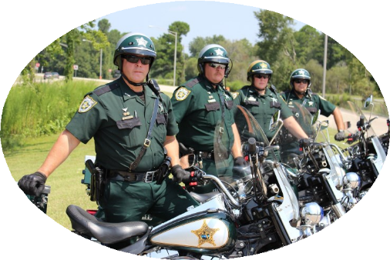

# **Nassau County Sheriff’s Office**Nassau County Sheriff police car

# Elderly retired police officer posing with a police car.Male police officer smiling in front of a police car.Female police officer smiling in front of a police car.A Nassau County Sheriff employee working on a computer with multiple screens.Police officer with a police dogKeeping our Community Safe