NASSAU COUNTY SHERIFF’s OFFICE

A Dual Accredited Florida Law Enforcement Agency

s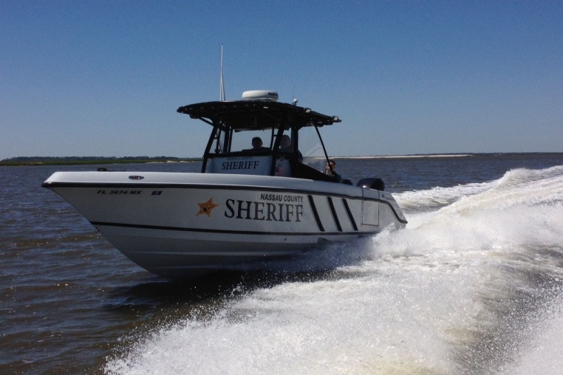

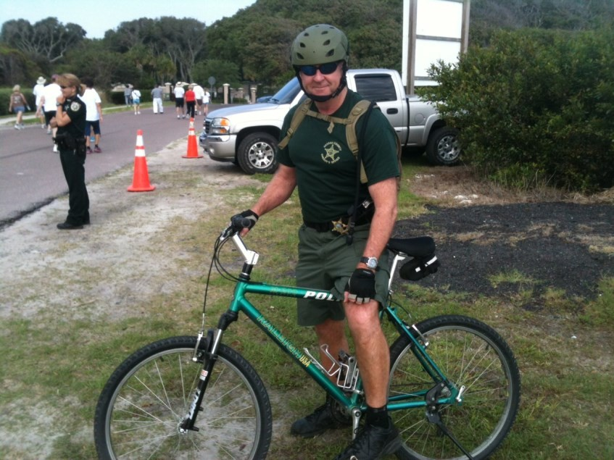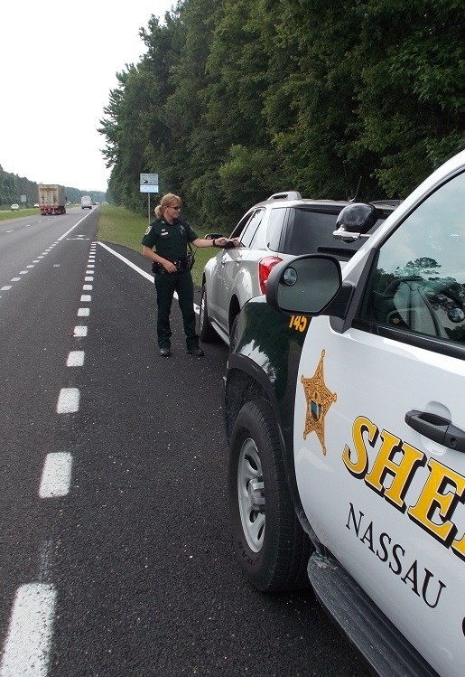
Interested in a Career in Law Enforcement?
Contact the Nassau County Sheriff’s Human Resource Office today!
Call 904.548.4063 or visit
www.nassauso.com

