Closing Your Doors to Burglary
Author: Sheriff Bill Leeper

Doors

Hinge Doors
The most common door type used in homes and apartments is the hinge door. It is important that all exterior doors be of solid wood core construction or that steel clad doors be used. Avoid light gauge aluminum. Hollow core or composition board doors are not effective deterrents because they can be easily battered or bored. It is defeating the purpose of a good deadbolt lock to mount it on a hollow or foam core door. If door hinges are exposed on the exterior of the door, non-removable hinge pins should be used. To prevent removal of a door that has removable hinge pins, you can employ a headless screw or nail. Insert the headless screw or nail into the leaf on the door frame side. Allow the screw or nail to protrude 1/2”. When the door is closed, the screw will engage the other hinge leaf.

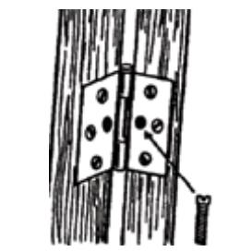
(Illustration of side of door frame, with arrow pointing at middle hinge hole. Captions reads: Drill a hole in the center of the hinge and insert a headless screw or nail to the door frame side, allowing it to protrude approximately one half inch. Inspect the door frame and repair any splitting or rotting.)

Glass in the Door
Problem:
- If glass is within 40 inches of the inside turn latch, a burglar can break the glass, reach in and open the door.

Solutions:
- Install a double cylinder deadbolt lock. However, be aware of potential fire hazards and do not use a double cylinder deadbolt in a mobile home.
- Cover the glass with polycarbonate (plastic) sheet.
- Add a decorative grill or grill door.
- Replace the door with a solid core door.

Points to Remember:
- Polycarbonate sheets and metal grill doors may be more expensive than replacing the door. If the door is replaced with a solid core or panel door, a wide angle door viewer is also recommended.
- A double cylinder deadbolt lock (keyed from both sides) is recommended only if the resident understands the potential fire hazards.

Locking Out Trouble
Sound locks won’t always keep out a burglar, but they will discourage one. You don’t need to spend a lot of money on security hardware, but you should follow the guidelines listed in order to protect your family. Since prices vary, you should shop around.
Chain latches offer NO security because they can be ripped off easily. Instead, check a caller’s identity through a wide angle viewer or peephole. (Min. 180 degrees)

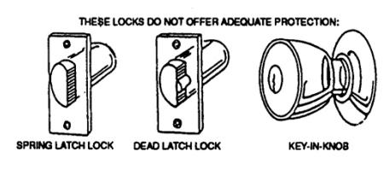
(Illustration of 3 types of locks; Spring Latch, Dead Latch and Key-In-Knob. Captions reads: These locks do not offer adequate protection.)

A common type of lock in many homes and apartments is the key-in-knob or spring latch type. This particular lock is easily defeated by the most amateur burglar with a credit card or screwdriver inserted between the latch and the strike plate. This lock offers no security and should be supplemented by a single or double cylinder deadbolt lock, rim type or surface mounted lock. The dead latch is similar to the spring latch lock but has a small bar or plunger which will not permit opening with a shimming device.
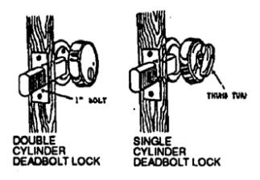
(Illustration of 2 door locks; Double Cylinder Deadbolt Lock, Single Cylinder Deadbolt Lock.)

A single cylinder deadbolt lock should be mounted on a solid wood core door when there is no breakable glass within 40 inches of the interior locking mechanism. The single cylinder deadbolt lock has a thumb turn piece on the inside.

A double cylinder deadbolt lock, which is key operated from both the interior and exterior, should be used when there is glass within 40 inches of the interior locking mechanism. (CAUTION: The use of a double cylinder deadbolt lock can be a fire hazard. If this type of lock is used while the home is occupied, either leave a key in the lock or hanging somewhere near the lock. Children should be trained to use this lock and know the exact location of the key. When the dwelling is unattended, the from view and out of the reach of the burglar who may break the glass.)

When moving into a new dwelling, have tumblers in all exterior locks changed. This can be done inexpensively by a licensed locksmith.

Components of a Good Deadbolt
Both single and double cylinder deadbolts should meet these basic criteria to be a good security device.

- The bolt must extend a minimum of 1” throw and be case hardened or contain a hardened insert.
- The cylinder guard must be tapered or spherical to make it difficult to grip it with pliers or a wrench. It must be made of solid metal, preferably able to turn freely.
- The connecting screws that hold the lock together must be on the inside. There must be no exposed screw heads on the exterior of the door.
- The connecting screws must be at least 1/4” in diameter and screw into solid metal sock, not screw posts.
- The screws that come with the strike plate are often short. Use 2” screws in the strike plate.
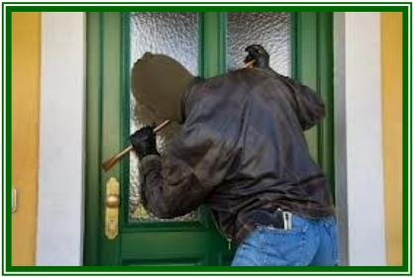
(Photo of burglar breaking into door using a crowbar)

Windows

Sliding Glass Windows/Doors
Sliding glass windows can be secured in the same manner as sliding glass doors. Pins through the frame (at an angle), screws in the track or keyed locks can all be used. Many inexpensive auxiliary locks are available.

Problems:
- Aluminum (thin gauge) can be peeled to gain entry.
- Window can be lifted out of track.
- Window can be forced open.

Solutions:
- Tighten adjustment screws to prevent lifting door out of channel.
- Charley bar or sliding door bar (placed at mid -height) may be purchased.
- Numerous locking devices are available for sliding glass windows and doors.

Double Hung Windows

Problems:
- Can be easily jimmied open with a screwdriver.
- By prying against the hardware, screws can be popped out.
- Glass can be broken adjacent to the crescent latch.

Solutions:
- Drill and pin at an angle.

Points to Remember:
- Drilling and pinning is an inexpensive and effective solution. If a nail is used, 5/32” with 8 or 10 penny nails are recommended.
- Commercially produced window pins are available. Beware of the type which requires a wrench due to potential fire hazard.
- All ground floor windows should be locked. (Exception: If small children live in the home, one window should be designated as a fire emergency exit.)
- Key operated locks are easy to install. If one is used, the key should always hang on a nail next to the casing for emergency use.

For more information, contact the Nassau County Sheriff’s Office: 904-225-0331 / 904-879-3853
Emergency: 911
Visit us online at www.nassauso.com

