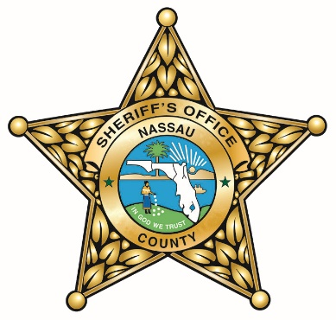
NASSAU COUNTY SHERIFF’S OFFICE
INFORMATION ON TAKING
THE CRIMINAL JUSTICE BASIC ABILITIES TEST

Individuals who apply to be a Correctional Officer with the Nassau County Sheriff’s Office and are not Florida State Certified in Corrections must take the Criminal Justice Basic Abilities Test (CJBAT) prior to submitting their application.

The CJBAT is based on a job task analysis (JTA) in both Law Enforcement and Corrections, adopted by the Criminal Justice Standards and Training Commission (CJSTC) pursuant to Section 943.17, F.S. The CJBAT predicts the likelihood for success in basic recruit training and the State Officer Certification Examination (SOCE).

It assesses written comprehension and expression, information ordering, spatial orientation, memorization, problem sensitivity and inductive and deductive reasoning. The CJBAT is a multiple-choice test in a computer-based or paper and pencil format. The test will take approximately 2.5 hours to complete. The CJBAT is administered only within the state of Florida and the score is valid for four years from the date of the test.

There are a few locations in the Northeast Florida where the test is administered. Fees and scheduling are unique to each location. The applicant should contact them directly for more information. Below are links to a few locations.

- Florida State College at Jacksonville
www.fscj.edu/admissions-aid/assessment-and-certification/available-assessments/cjbat

- St. Johns River State College, Palatka Campus
www.sjrstate.edu/testdates.html

- Florida Gateway College, Lake City, Florida
https://www.fgc.edu/students/test-center/

If there are any questions, please contact the Nassau County Sheriff’s Office Human Resources office at 904-548-4054 or 904-548-4012.

The Nassau County Sheriff’s Office is an Equal Opportunity Employer
And
A Drug Free Workplace

